

G. H. Raisoni College of Engineering & Management

Department of Computer Engineering

TAE 1 (Activity Based Learning)

SOFTWARE REQUIREMENT SPECIFICATION(SRS)

Topic: **Railway Reservation System**

Subject: *Data Structure*

Submitted to:

Mrs. Pournima More **GROUP A1**

|  |  |
| --- | --- |
|  | Submitted by: |
| **SCOB01** | Abhijit H Jadhav |
| **SCOB06** Shrikrishna Bhure | |
| **SCOB11** | Harshal Indave |

**Table of Contents**

1. **INTRODUCTION**

1.1. Objective

1.2. Scope

1. **ABSTRACT**

2.1. Variable used

1. **DATA FLOW DIAGRAM**
2. **REQUIRMENT SPECIFICATION**
   1. Hardware Requirements
   2. Software Requirements
3. **CODING AND OUTPUT**
4. **ADVANTAGES**
5. **LIMITATIONS**
6. **REFERENCES**

**1.Introduction**

A **Software Requirements Specification** (**SRS**) is a complete set of information about the system on which the developed project will be running. It includes all the hardware as well as the software requirement. The minimum system requirement as well as the recommended system requirement for running the software are also mentioned in detail separately. The aim of this document is to gather and analyze and give an in-depth insight of the complete software requirement of the **Railway reservation system**.

* 1. **Objective**

The purpose of this source is to describe the railway reservation system which provides the platform for the customer to do the reservation of the seats in the railways. It also provides the passenger with the facility of the cancellation of the reservation, train timing details, check the seat availability, tatkal reservation, insurance and train availability.

**1.2 Scope**

“Railways Reservation System” is an attempt to simulate the basic concepts of an online reservation system. This project is dedicated to model existing railway reservation systems that aim at development of Railway Reservation System that facilitates the railway customer to manage their reservations and the railway administrator to modify the backend database in a user-friendly manner. The system enables to perform the following functions:

* Search for a train: It enables the user to search for the trains from his source to the destination of travel.
* Check seat availability: It enables the user to check the availability of the seats for a train before booking the ticket.
* Tatkal reservation: It gives the user the facility to do the reservation on the urgent basis with extra charges.
* Reservation of the ticket: It enables the user to do the reservation.
* Cancellation: It provides the user with the facility to cancel the ticket at any instant of time.
* Insurance facility: It provides the insurance facility that insures the life of the passenger.
* Improved & optimized service: Provides a well versed and optimized service.
* Railway Database:
* Add the Trains in the railway database
* Display the trains
* Insert the trains
* Sort the trains
* Search the trains
* Modify the trains data
* Delete the trains from database
* Take the Backup of the database

**2. Abstract**

In the Railway reservation system, we have tried to develop a platform to make the reservation system more efficient, easier and fast. It explains the systematic procedure of railway reservation in India. This project is developed using the C language. Which the best and the most used language in the Procedure oriented programing languages. Various functions and structures are used to make a best use of this language.

Railway reservation system enables us to do the train reservation and other things there is necessity to fill a form at the railway reservation counter, that is the user can directly select from the choices provided with train numbers, origin, date of travel, departure time, destination, arrival time at that station, the class of travel, insurance etc. The program gives user the final output as train ticket with the amount to be paid. Finally, it’s the user who has to decide whether to book the ticket or not.

The railway reservation system is used for booking the ticket, searching for the trains, checking the availability of the seats, for doing the tatkal reservation and for the cancellation of the ticket. The most important facility provided in this system is of the insurance policy, that is the passenger will get the financial support if any accident of train or other thing happened during the travel.

This railway reservation system is beneficial to all the user who have to book the ticket online instead of standing in the long queues at the reservation counter. This system can also be used by the Railway reservation authorities for doing the reservations.

**2.1 Variables used**

In this Railway reservation system program, the variables used are as follows:

1. For Ticket Booking

* Source: It is the place from which the passenger wants to travel.
* Destination: the place to which the passenger wants to reach.
* Date of the Journey: On which the day the passenger wants to travel in train.
* No. of passengers(adult/child): total number of passengers including the adults and children’s.
* Name of each passenger
* Age of each passenger
* Gender(M/F)
* Mobile no:
* E-mail:
* Class (Sleeper/AC 2 tier/ AC 3 Tier)
* ID type (Aadhar Card / Pan card no. / Voting card no.

1. Railway Database

* tno: Train Number
* tna: Train Name
* ttt: Total train Duration
* src: Source of Travel
* dest: Destination of Travel
* arr: Arrival Time
* dept: Departure Time
* km: Kilometers

1. Backup of Data

* Import: Import the Data form the backup file
* Export: Export the Data into the file
* After accepting all the details at the end, the system will calculate the total fare based on the no. of km of distance and then it will show the total fare and will further go for the Payment of the money if the user chooses the Book option.
* It will also give the option of to cancel the already booked ticket.

**3.Flow diagram**

USER

ADMIN

Flow Chart to Book a Ticket

Enter the Source, Destination, Date of travel

No of passenger

Enter the Name, Age, Gender, Mobile no etc

Edit or display information

Display the Entered Details

Book ticket Or Exit

Railway Database

Display the Ticket

Book

1. **Requirement Specification**

It specifies the hardware requirements like memory restrictions, cache size, the processor, RAM size etc... those are required for the software to run.

**4.1 Hardware requirements**

**Minimum Hardware Requirements**

Processor: Intel Pentium III / Intel core to duo (any singe core with clock frequency of 1.00 GHz)

Hard disk drive :40 GB

RAM :500 MB

Cache:512 kb

Keyboard, mouse and all other necessary hardware devices

**Preferred Hardware Requirements**

Processor: Pentium IV or advanced

Hard disk drive: 80 GB

RAM: 1 GB

Cache: 1 MB

**4.2 Software requirements**

1. Operating System: Windows XP and above, all Linux Operating system
2. Dos Emulator is mandatory.
3. Compiler required: Turbo C++, GNU Compiler (Code block), Code Warrior etc.
4. The systems must be connected via LAN and connection to internet is mandatory.
5. **Advantages**
6. **User Friendly**: Easy to use and operate.
7. **Secure**: The transactions are secured with 64 bits to bit encryption.
8. **Reliable:** The project is very much reliable.
9. **Supportability**: Support almost to all systems.
10. **Maintainability:** Easy to maintain.
11. **Limitations**
12. Not very good Graphical User Interface.
13. Repeatability may be needed if any mistakes are done by user during insertion of the data.
14. **References**
15. [www.google.co.in](http://www.google.co.in)
16. [www.wikipedia.com](http://www.wikipedia.com)
17. [www.quora.com](http://www.quora.com)
18. [www.irctc.co.in](http://www.irctc.co.in)
19. [IEEE](http://www.quora.com) SRS format

**5. Coding And Output**

Output:

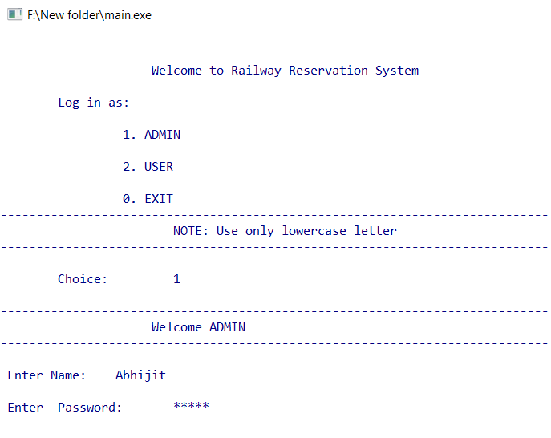

* Admin Menu

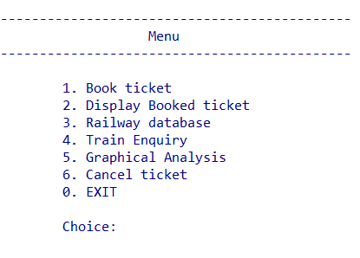

* Ticket Booking

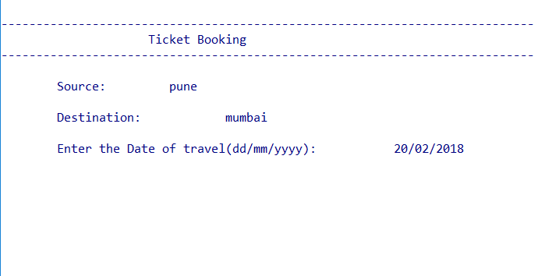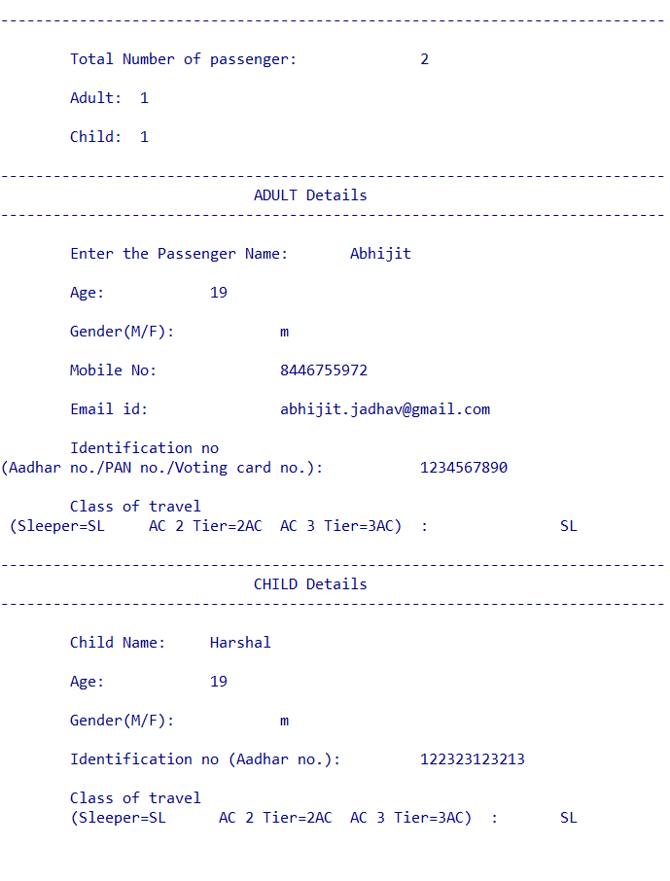

* Select train and Payment

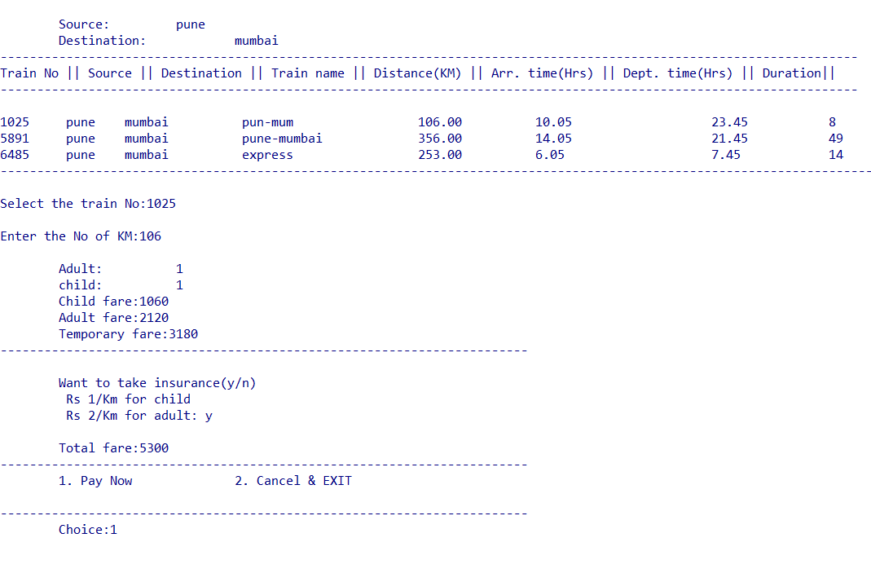

* Railway Database Menu

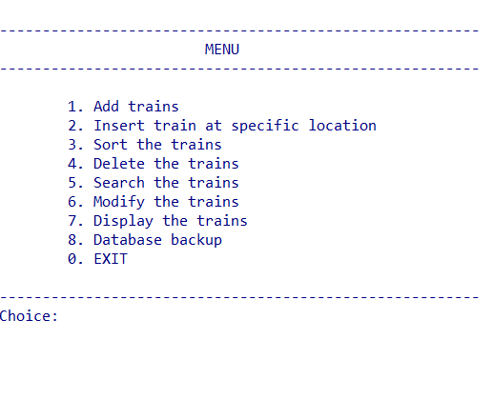

* Train Enquiry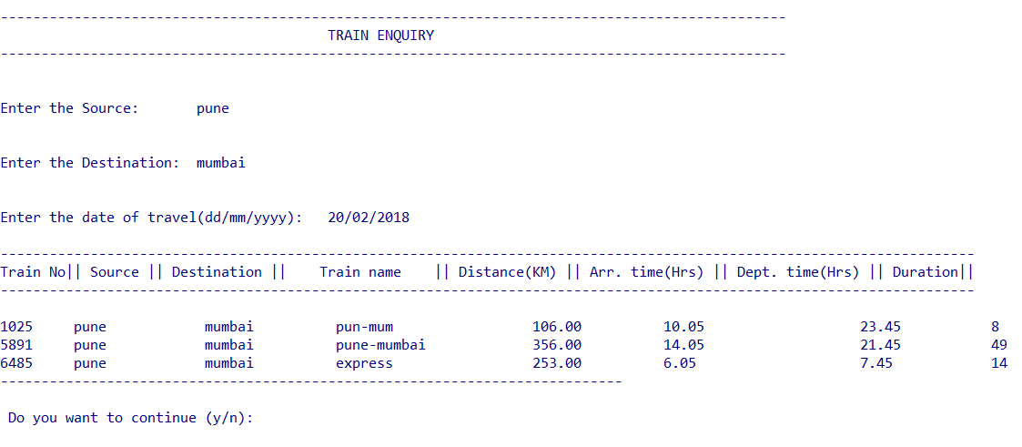
* Graph Analysis

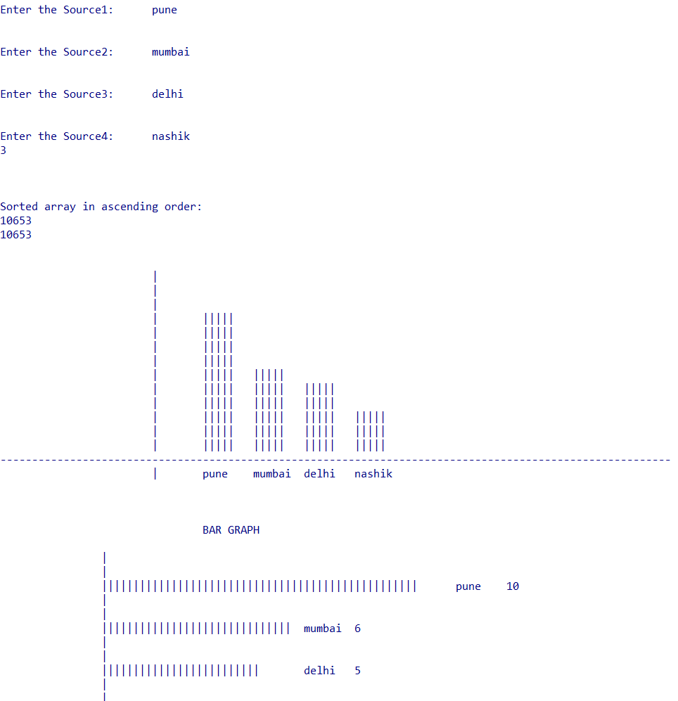



* Avaliable Trains in Database

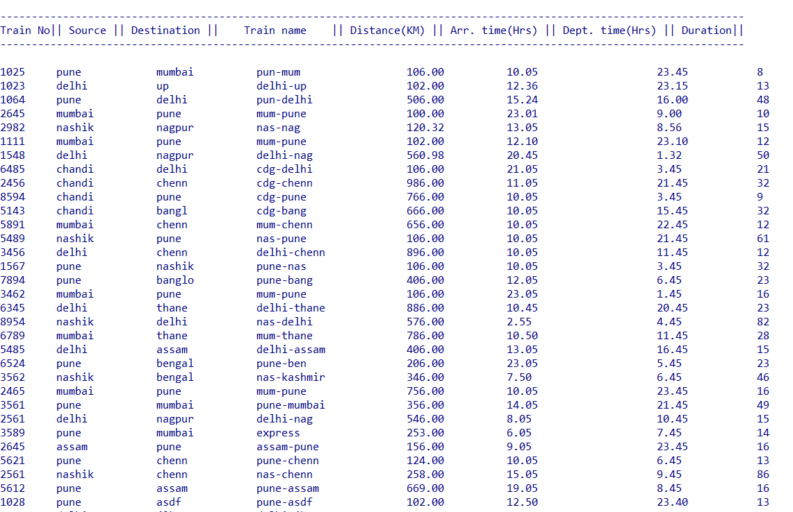

**Module 10A**

**Module 10B**